Chapter 1: Tour of WICED Wi-Fi

Time 1 Hour

After completing Chapter 1 (this chapter) you will understand a top-level view of the components of the WICED ecosystem including the chips, modules, software, documentation, support infrastructure and development kits.

1.1 Tour of WICED Studio SDK 2

1.1.1 First Look 2

1.1.2 Project Explorer 4

1.2 Tour of Documentation 7

1.2.1 In the SDK Workspace 7

1.2.2 On the Web 7

1.3 Reporting Issues 9

1.4 Tour of WICED SDK Structure 10

1.5 Tour of Wi-Fi 10

1.6 Tour of Chips 10

1.7 Tour of Partners 12

1.8 Tour of Development Kits 13

1.8.1 Cypress CYW943907AEVAL1F 13

1.8.2 Cypress CYW94343WWCD1\_EVB Evaluation and Development Kit 13

1.8.3 Future Nebula IoT Development Kit 13

1.8.4 Avnet BCM4343W IoT Starter Kit 14

1.8.5 Adafruit Feather 14

1.8.6 Electric Imp 14

1.8.7 Inventek 15

1.8.8 Particle Photon 14

1.8.9 SparkFun with Particle Photon Module 15

1.9 Exercise(s) 16

Exercise - 1.1 Create a forum account 16

Exercise - 1.2 Open the documentation 16

# Tour of WICED Studio SDK

## First Look

The WICED software tool is called “WICED Studio” and it is based on Eclipse.

WICED Studio is installed, by default, in *C:/Users/<UserName>/AppData/Local/WICED.* As a part of installing WICED Studio, an SDK Workspace is created, by default, in *C:/Users/<UserName>/My Documents/WICED-Studio-<version>/43xxx\_Wi-Fi*. The SDK Workspace is where you will create your projects. Note that a new set of SDK Workspace files is created for each version of WICED Studio that you install. If you install a newer version of WICED Studio, your projects from the previous version will still be available in the SDK Workspace location associated with that previous version of WICED Studio. You must copy them over manually if you want to access them in the new version.

Once installed, WICED Studio will show up in Windows under Start > All Programs > Cypress > WICED-Studio. The first time you open WICED Studio, you will be asked for which platform you want to use. We will use *43xxx\_Wi-Fi* for this class, but if you used a different selection don’t worry – you can change it easily from inside the tool using the dropdown menu.

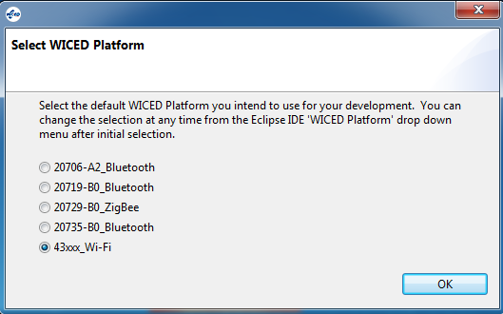



The major windows are:

1. File Editor
2. Project Explorer
3. Make Target
4. Console
5. Help

If you close a window unintentionally, you can reopen it from the menu *Window > Show View*. Some of the views are under *Window > Show View > Other…* You can drag and drop windows and resize them as you desire.

## Project Explorer

If you expand 43xxx\_Wi-Fi from the Project Explorer window you will see the following:

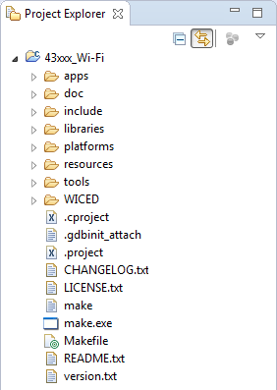

The README.txt file provides basic information about the SDK. This file is open by default in the editor window when the SDK is first opened. The file version.txt contains details of the version of WICED Studio that you have open. Other folders of interest in the Project Explorer are:

### Apps

The *apps* folder is where all the example projects reside as well as where you will put your own projects. The SDK Workspace includes a wealth of example projects. These are broken into categories by folder name. A few of the useful ones are:

1. *snip*: Short examples that typically demonstrate one feature. For example:
   1. *snip/gpio* demonstrates GPIO use by reading buttons and blinking LEDs.
   2. *snip/scan* scans for Wi-Fi access points every 5 seconds and displays the results to a terminal window.
2. *demo*: More complex and complete demonstrations. For example:
   1. *demo/temp\_control* demonstrates an application for controlling and reporting temperatures.
   2. *demo/bt\_smartbridge* demonstrates a Bluetooth to Wi-Fi bridge.
3. *test*: Test and utility programs.For example:
   1. *test/console* provides a console application on a terminal window. Type “help” in the console for a list of all supported commands such as scanning for and connecting to Wi‑Fi access points.

### Doc

The doc folder contains the documentation for the SDK Workspace. Of particular interest is the API.html file which documents all of the WICED API functions. It is usually easier to use that file if you open it in a web browser of your choice rather than from inside WICED Studio. You can do this from WICED Studio by right clicking on API.html and choosing “Open With > System Editor”. Depending on your web browser and settings, you may have to tell it to allow ActiveX controls to see the menus.

The first window you will see when you open the **API.html** file is shown below. You can enter search strings in the box in the upper-right corner. The list will filter dynamically as you type. For example, if you enter “wiced\_gpio” you will see a list of all WICED APIs that are used for controlling IOs.

Note: sometimes the search feature stops working. If this happens, close the browser page and reopen it.

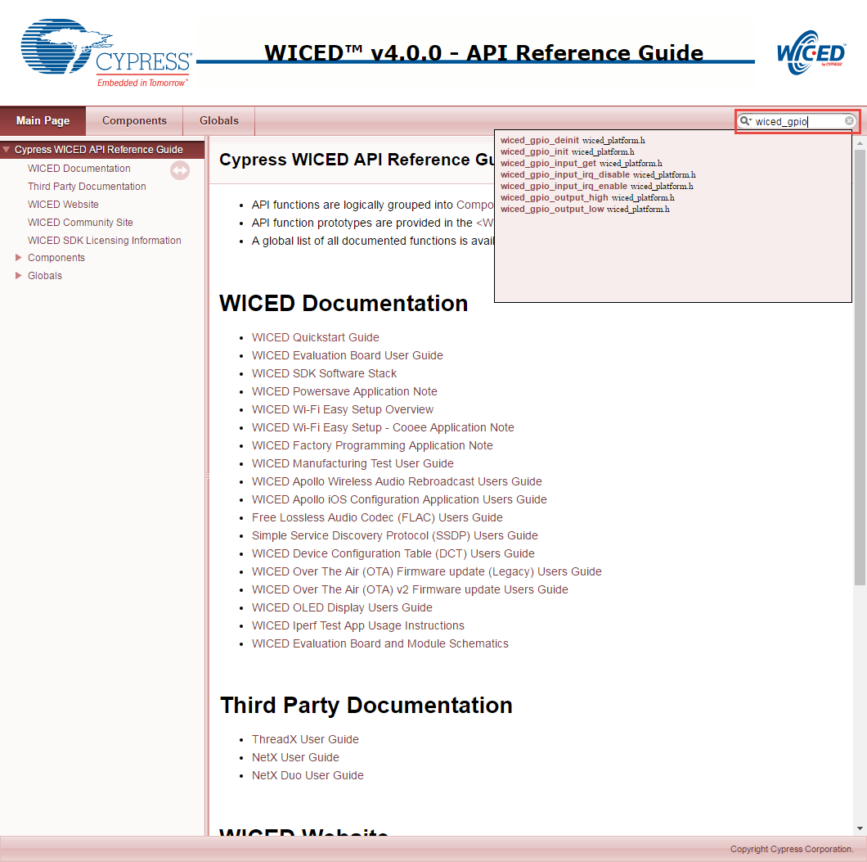

### Platforms

The platforms folder contains information on different kits (i.e. hardware platforms). These files are necessary in order to program a given project into specific hardware. In our case, the kit we are using is called CYW943907AEVAL1F. That kit has a platform folder, but since we are also using a shield attached to it, we will use a custom set of platform files that also includes the peripherals on the shield. You will have to copy over the custom platform files before using the shield and kit (this will be the first exercise in Chapter 2). You can even create platform files for your own custom hardware that you design. We’ll discuss the platforms folder in more detail in Chapter 2.

### Libraries

The libraries folder contains various sets of library function files. For example, there are libraries for working with file systems (in the filesystems folder), for using U8G graphics displays (in the graphics folder), and for reading JSON (in the utilities folder). We will discuss the libraries folder in more detail in Chapter 4.

### Resources

The resources folder is where you store files that are required by your application. For example, if your application contains a web server, the html files for the server would be in the resources folder under *apps/https\_server*. As another example, security certificates also go in the resources folder.

# Tour of Documentation

## In the SDK Workspace

As discussed previously, the doc folder in the SDK Workspace contains various documents. The most important of these is the API guide but the folder also contains other useful documents such as the QSG (Quick Start Guide), how to use DCT (Device Configuration Tables), FLAC (Free Lossless Audio Compression), and OTA (Over the Air) Updates. The list of files in the doc directory looks like this:

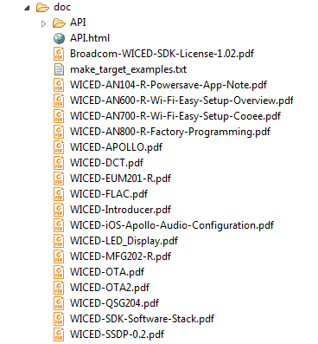

Each of the files in the doc folder can be accessed either from within the WICED Studio (the Project Explorer pane) or from Windows Explorer.

## On the Web

Navigating to “[www.cypress.com](http://www.cypress.com) > Design Support > Community” will take you to the following site (the direct link is <https://community.cypress.com/welcome>):

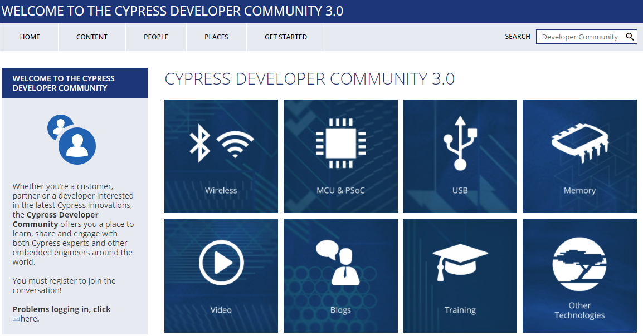

Clicking on the Wireless icon and then the WICED Studio icon will take you to the community page as shown below. From this page, you can download WICED Studio, purchase kits, search for answers, ask questions, etc.

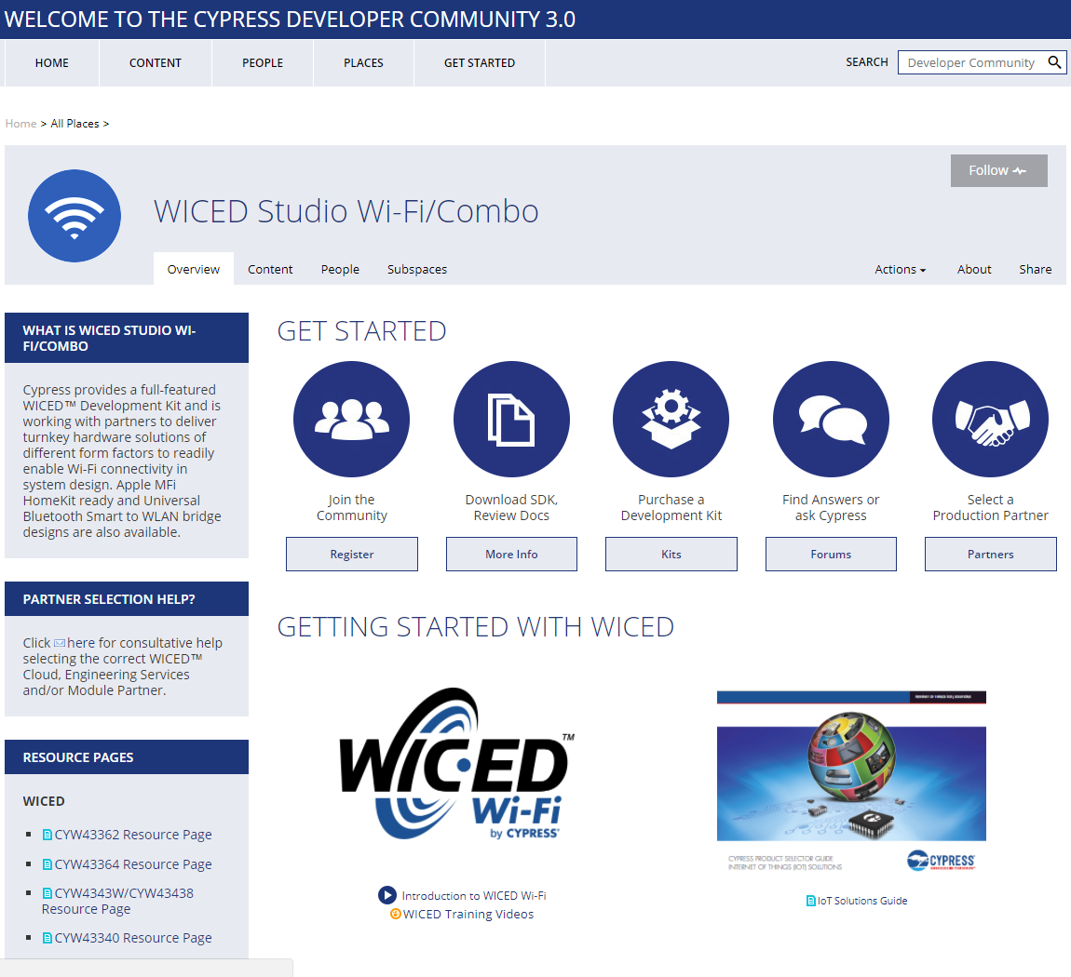

# Reporting Issues

If you are a Cypress employee and you find an issue in WICED Studio (bug, missing or confusing documentation, enhancement request), please use a “JIRA” to report it. Non-Cypress employees should report issues via the forum. JIRA can be accessed at:

[jira.cypress.com](http://jira.cypress.com/)

Click on Create to start submitting a JIRA. Use the project type of SW-WICED and fill in as many details as you can to report the issue. If you are reporting an issue with a kit, use “KITS:” as a prefix to the summary.

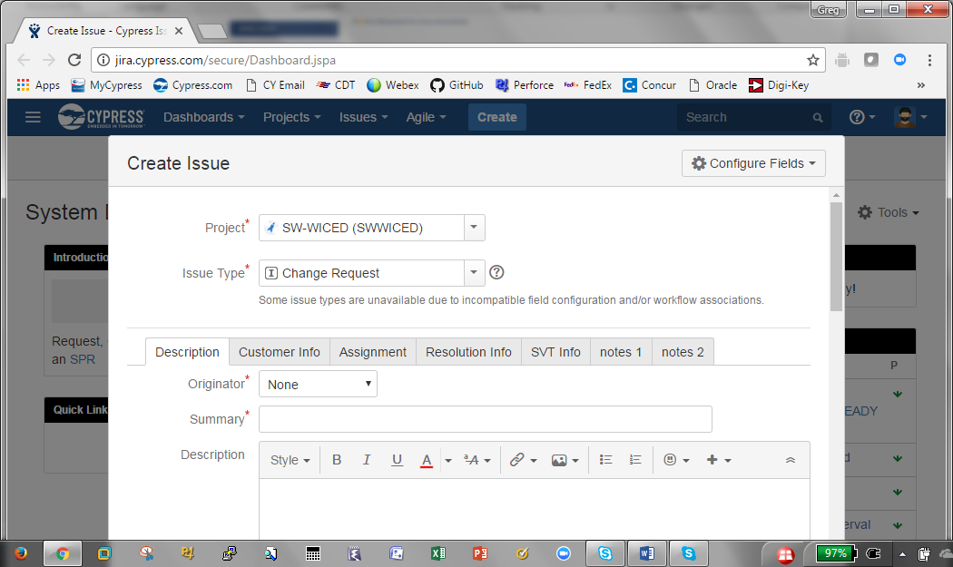

# Tour of WICED SDK Structure



# Tour of Wi-Fi

|  |  |  |  |  |  |  |
| --- | --- | --- | --- | --- | --- | --- |
| **IEEE**  **Standard** | **Mbits/s** | **Freq**  **GHz** | **#**  **Chan** | **Chan Width**  **MHz** | **MIMO** | **Comment** |
| 802.11 | 2 | 2.4 | 14 | 22 | - |  |
| [802.11b](https://en.wikipedia.org/wiki/IEEE_802.11b-1999) | 11 | 2.4 | 14 | 22 | - | Same as 802.11 with new coding scheme |
| [802.11a](https://en.wikipedia.org/wiki/IEEE_802.11a-1999) | 54 | 5 | 22 | 20 | - | New coding scheme OFDM + 5GHz |
| [802.11g](https://en.wikipedia.org/wiki/IEEE_802.11g-2003) | 54 | 2.4 | 14 | 22 | - | New coding scheme OFDM |
| [802.11n](https://en.wikipedia.org/wiki/IEEE_802.11n-2009) | 600 | 2.4  5 | 14  22 | 20/40 | 4 | MIMO=Multiple Antennas  4 streams of 150Mbits/s |
| [802.11ac](https://en.wikipedia.org/wiki/IEEE_802.11ac) | 3600 | 2.4  5 | 22  10  5  1 | 20  40  80  160 | 8 | 433Mbits/s per stream  Beam forming directional |
| 802.11ax | 10,000 | 2.4  5 |  | 20  40  80  160 | 4x4 |  |

# Tour of Chips

|  |  |  |
| --- | --- | --- |
| **Device** | **Key Features** | **Notes** |
| CYW43362 | * Single band 2.4GHz * 1x1 11n * Modules paired w/ STM32F205 and STM32F411 | Recommend new designs with 43364 |
| CYW4390 | * Single band 2.4GHz * 1x1 11n | Recommend new designs with BCM43903/7  Black Box Only |
| CYW43340 | * Dual band combo 2.4GHz and 5GHz, 1x1 11n * BT4.0/BLE | Currently only production dual band combo in single chip for WICED RTOS SDK |
| CYW43364 | * Single band 2.4GHz, 1x1 11n * Next Gen BCM43362 | Lower power and cost compared to BCM43362 |
| CYW4343W | * Single band combo 2.4GHz * BT4.1/BLE | Lower cost and power compared to BCM43340 |
| CYW43903 | * Single band 2.4GHz , 1x1 11n * SOC w/ ARM CR4 160Mhz * 1MB on chip RAM * Secure OTP and HW crypto engine | Lower cost solution for White Box  High end Black Box features |
| CYW43907 | * Dual band 2.4 and 5GHz, 1x1 11n * SOC w/ ARM CR4 320Mhz * 2MB on chip RAM * Secure OTP and HW crypto engine | Ideal solution for White Box  Multiple low power modes |

# Tour of Partners

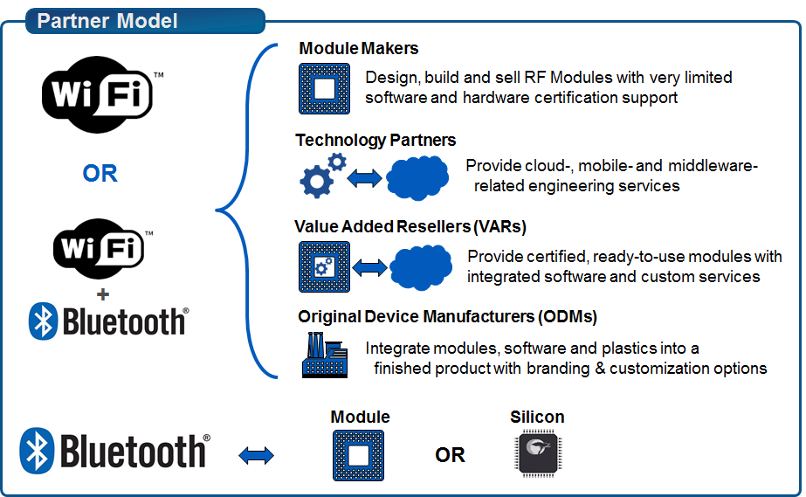

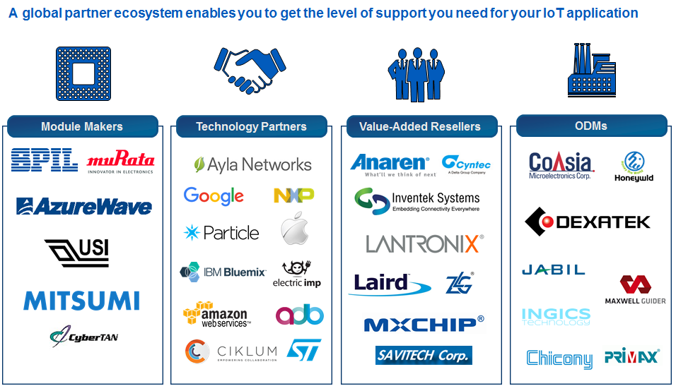

An IoT Selector Guide including partner modules available can be found in the Community at:

<https://community.cypress.com/docs/DOC-3021>

# Tour of Development Kits

## Cypress CY8CKIT-062-WiFi-BT

* 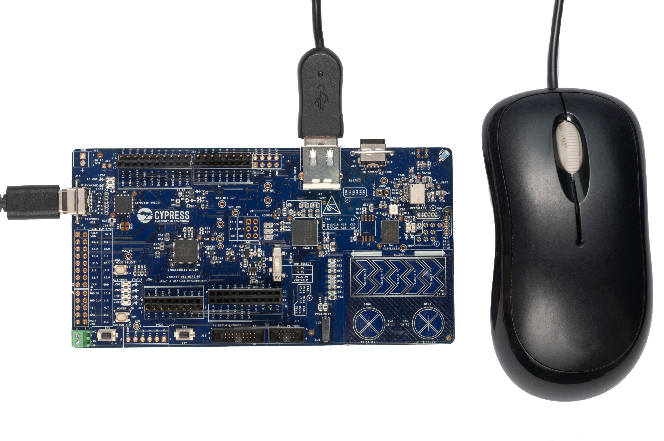Wi-Fi + BLE combo kit (CYW4343W)
* PSoC 6 with 150MHz M4 and 100 MHz M0+
* 1MB Onboard Flash, 512 MB External Flash, 288kB SRAM
* CCG3 USB Type-C Power Delivery
* USB host and device support
* CapSense Buttons, Slider, and Proximity
* 1 User Mechanical Button, 2 LEDs, 1 RGB LED
* Includes a CY8CKIT-028-TFT Display Shield

## C:\Users\Greg\Desktop\IMG_20170403_194435.jpg[Cypress CYW943907AEVAL1F](http://www.cypress.com/documentation/development-kitsboards/cyw943907aeval1f-evaluation-kit)

* Dual band 2.4 and 5GHz WiFi, 1x1 11n
* Ethernet
* SOC w/ ARM CR4 320Mhz
* 2MB on chip RAM
* Secure OTP and HW crypto engine
* USB JTAG Programmer/Debugger

## [Cypress CYW94343WWCD1\_EVB Evaluation and Development Kit](http://www.cypress.com/documentation/development-kitsboards/bcm94343wwcd1evb-evaluation-and-development-kit)

* Wi-Fi + BLE combo kit (CYW4343W)
* 512kB Flash, 128kB SRAM, 8Mb SPI Flash
* 2 User Buttons, 2 User LEDs
* Thermistor
* USB JTAG Programmer/Debugger

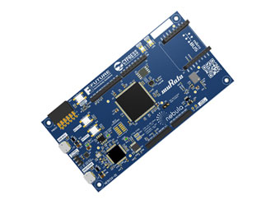

## [Future Nebula IoT Development Kit](http://www.futureelectronics.com/en/Technologies/Product.aspx?ProductID=NEB1DX01FCS1089735)

* Murata 1DX module with
* Wi-Fi + BLE combo kit (CYW4343W)
* 2MB Flash, 256kB SRAM, 8Mb Serial Flash
* 2 User Buttons, 2 User LEDs
* Arduino, PMOD, and mikroBus Interfaces

**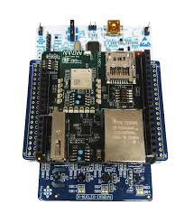**

## [Arrow Quadro IoT Wi-Fi Kit](https://cms.edn.com/ContentEETimes/Documents/EDN/WP_Arrow_Quadro_IOT_WiFi_Kit.pdf)

* Dual band 2.4 and 5GHz WiFi
* Ethernet
* 2MB on chip RAM
* Designed for mounting on a custom PCB

## Image for [Avnet BCM4343W IoT Starter Kit](http://cloudconnectkits.org/product/avnet-bcm4343w-iot-starter-kit)

* Wi-Fi + BLE combo kit (CYW4343W)
* 512kB Flash, 128kB SRAM, 8Mb SPI Flash
* 1 User Button, 2 User LEDs
* Ambient Light Sensor
* Arduino Compatible Headers
* USB JTAG Programmer/Debugger

## [Adafruit Feather](https://www.adafruit.com/products/3056)

* Wi-Fi kit (CYW43362)
* 128kB Flash, 16kB SRAM, 16Mb SPI Flash
* Programmable using Arduino IDE
* USB Bootloader

## [Electric Imp](https://www.electricimp.com/platform/)

* Wi-Fi kit (IMP003- CYW43362, IMP005 – CYW43907)
* Programmable using imp IDE

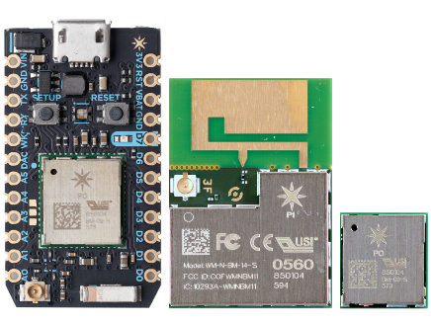

## [Particle](https://www.particle.io/products/hardware/photon-wifi-dev-kit) [Photon](https://www.particle.io/products/hardware/photon-wifi-dev-kit)

* Wi-Fi kit (CYW43362)
* 1MB Flash, 128kB SRAM

## [SparkFun with Particle Photon Module](https://www.sparkfun.com/products/13321)

* Wi-Fi kit (CYW43362)
* 1MB Flash, 128kB SRAM
* Arduino Compatible Headers

## [Inventek](http://www.inventeksys.com/)

ISM43362-M3G-EVB

* Wi-Fi Kit (CYW43362)
* 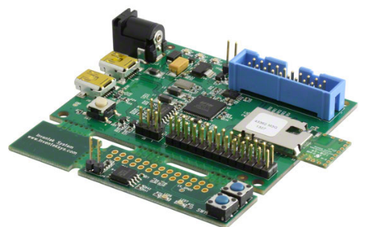2 User Buttons, 2 User LEDs
* Thermistor
* USB JTAG Programmer/Debugger

ISM43340-M4G-EVB

* Wi-Fi & Bluetooth Combo Kit (CYW43340)
* 2 User Buttons, 2 User LEDs
* 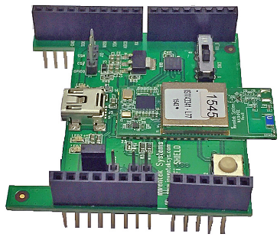Thermistor
* USB JTAG Programmer/Debugger

ISMART Arduino Shield

* Wi-Fi, Bluetooth, NFC Combo (CYW43362)
* Arduino stackable shield

ISM43340-L77-EVB

* 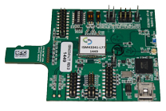Wi-Fi & Bluetooth Combo Kit (CYW43340)
* Wi-Fi over SDIO
* Bluetooth over UART
* Micro-SD Connector

# Exercise(s)

* 1. Create a forum account

1. Go to <https://community.cypress.com/welcome>
2. Click “Log in” from the top right corner of the page and login to your Cypress account. If you do not have an account, you will need to create one first.
3. Once you are logged in, click the “Wireless” icon and then the “Wi-Fi + Bluetooth Combo” icon.
4. Click on the “Forums” button.
5. Browse the existing forum articles or search for a particular topic that interests you.
   1. Open the documentation
6. Open the API.html document from the WICED Studio Project Explorer or using Windows Explorer in the SDK Workspace *doc* directory.

Depending on your browser and security settings, you may need to allow ActiveX controls to get the page to display correctly.

1. Navigate through the Project Explorer folders to see what is available in each:
   1. Demo and snip for example projects
   2. Libraries for helpful functions and utilities
   3. Doc for documentation
   4. Platforms for the supported kits
   5. Resources for additional app information